
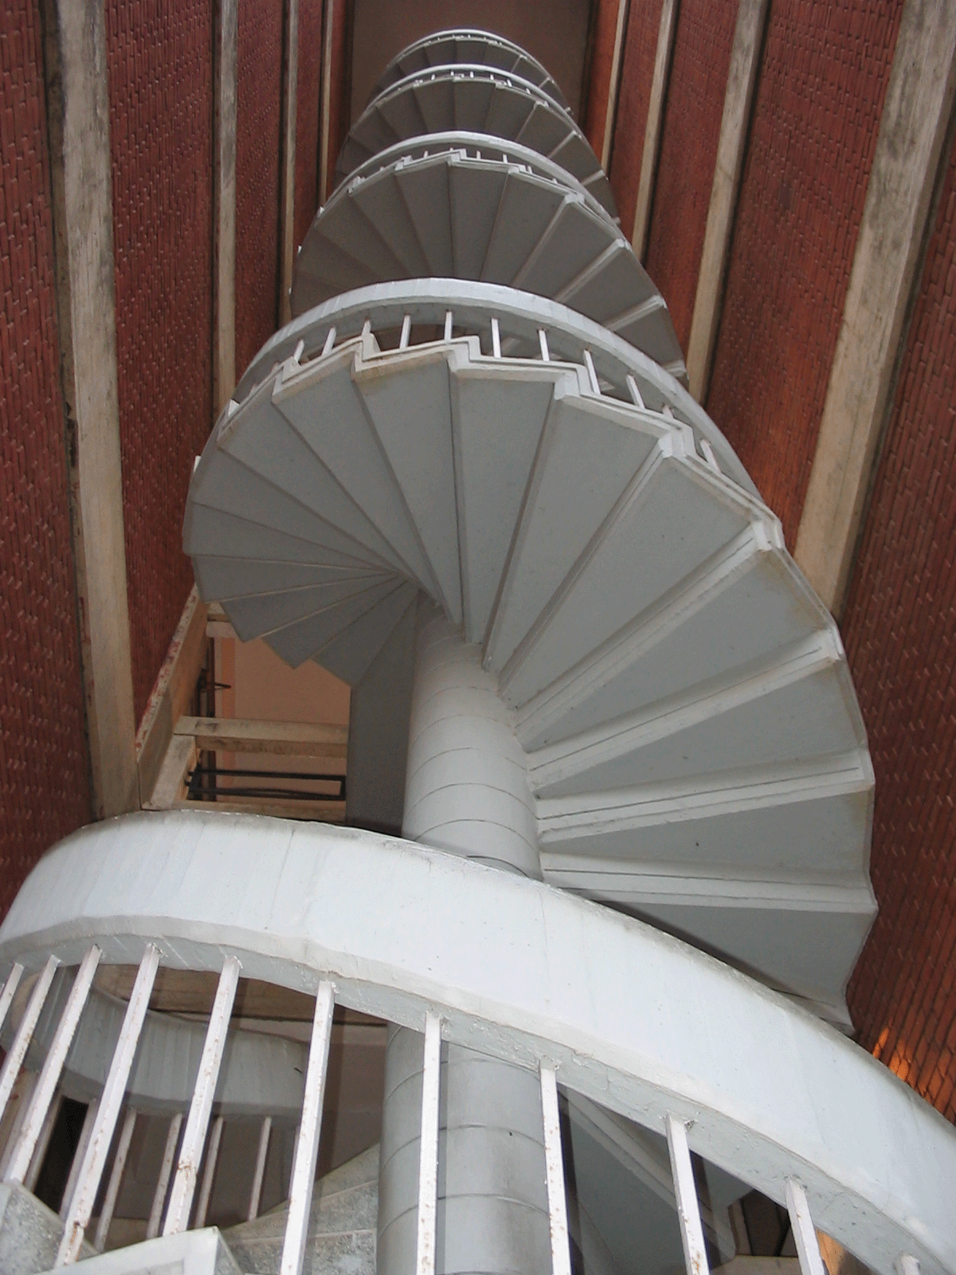
National Organizing Committee

Chairman
Prof. P.K. Kalra, Head, EE/ACES, IIT Kanpur

Reception Committee
Prof. Gurunath, IIT Kanpur
Dr. M. Nasim, DMSRDE, Kanpur
Dr. Rajendra Singh, ER&IPR, DRDO
Dr. V.R. Balakrishnan, SSPL, New Delhi

Technical Session Committee
Prof. R.K. Thareja, DOAA, IIT Kanpur
Prof. A.K. Dutta, IIT Kanpur
Prof. Utpal Das, IIT Kanpur
Prof. S. Ramakrishnan, IISc, Bangalore
Prof. K.S. Narayan, JNACR, Bangalore
Mr Bikash Kumar, Tata-BP Solar
Dr. Suresh Chandra, NPL, New Delhi

Publication Committee
Prof. S. Kar, IIT, Kanpur
Prof. Satyendra Kumar, IIT Kanpur
Prof. A.K. Pal, Jadavpur University, Kolkata
Prof. K.P. Vijay Kumar, Cochin University
Dr. Chetan Singh Solanki, IIT Bombay
Dr. P. Pradeep, NIT, Calicut

Hospitality Committee/
Accommodation/Logistics Committee
Prof. Sunder Manoharan, IIT Kanpur
Prof. R.B. Pode, Nagpur University
Mr. S.P. Gaba, IRDE, Dehra Dun
Dr. S.S. Bawa, NPL, New Delhi
Dr. Chandra Prakash, ER&IPR, DRDO
Dr. Ashok Kapoor, SSPL New Delhi

Publicity Committee
Prof. Deepak Gupta, IIT Kanpur
Dr. Kamalahasan, NPL, New Delhi
Mr. Durga Singh, IRDE, Dehra Dun

Industrial Relation
Prof. J. Kumar, Head, ACMS, IIT Kanpur
Mr. Vijay Kumar, GM-Technology, MBPV
Dr. A.K. Gupta, IRDE, Dehra Dun
Prof. Subhashish Ghosh, JNU, New Delhi

Convenor
Prof. Shafi Qureshi,
Department of Electrical Engineering
Indian Institute of Technology Kanpur 208016

Local Organising Committee
Dr. S.S.K. Iyer, IIT Kanpur, Coordinator Technical Sessions
Dr. Monica Katiyar, IIT Kanpur, Coordinator Reception
Dr. S. Panda, IIT Kanpur, Coordinator Publication
Dr. Anoop Singh, IIT Kanpur, Coordinator Hospitality
Dr. Ashish Garg, IIT Kanpur, Coordinator Accommodation
Dr. Santosh Tripathi, DMSRDE, Kanpur, Coordinator Publicity
Dr. T.H. Goswami, DMSRDE, Kanpur, Coordinator Logistics
Dr. Amitabh Verma, DGM- MBPV, Coordinator Industry Relation
Dr. R.S. Anand, IIT Kanpur, Organising Secretary

Registration:

Registration can be done by filling up the registration form provided on the conference website.

Our Sponsors:
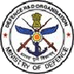







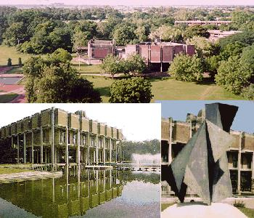


Department of Electrical Engineering
Indian Institute of Technology Kanpur

FIRST ANNOUNCEMENT AND
CALL FOR ABSTRACTS

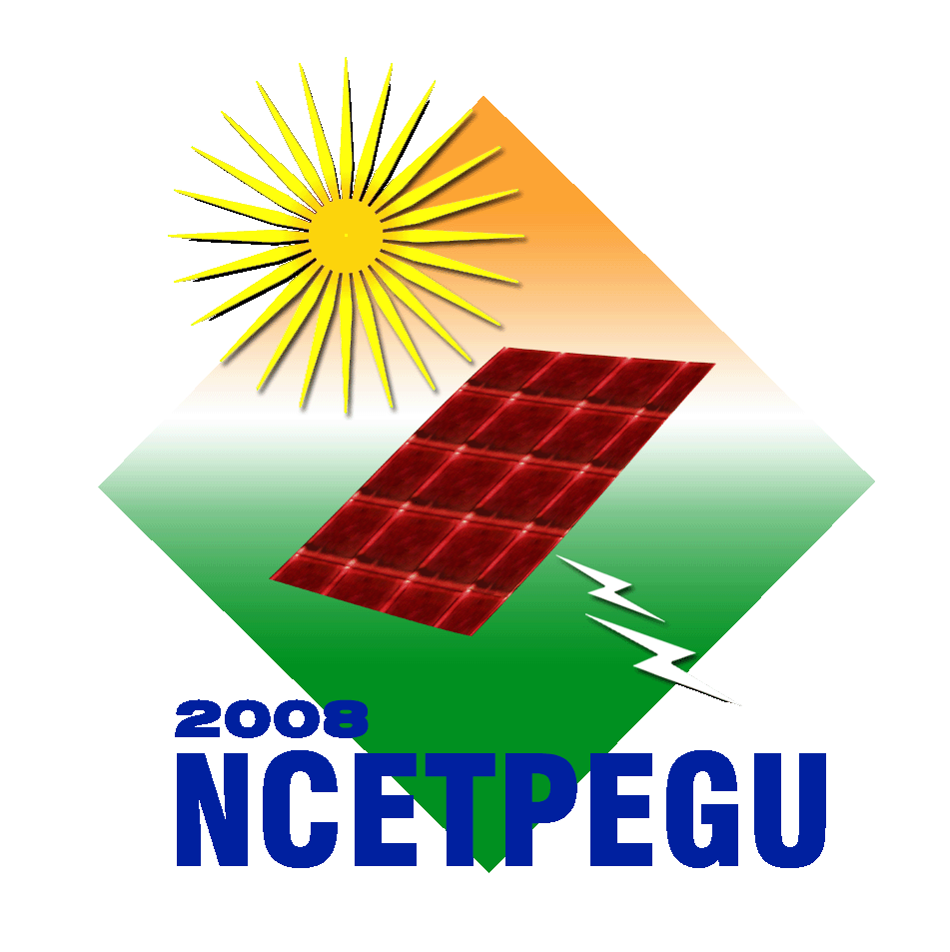
National Conference on the Emerging Trends in the Photovoltaic Energy Generation and Utilization

March 27-29, 2008

Conference Convenor:
Dr. Shafi Qureshi
Professor, Department of Electrical Engineering,
IIT Kanpur, Email- qureshi@iitk.ac.in
Phone: +91-512-2597133, Fax: +91-512-2590063

Organizing Secretary:
Dr. Raghubir Singh Anand
Senior Research Engineer,
Department of Electrical Engineering,
IIT Kanpur, Email- rsanand@iitk.ac.in
Phone: +91-512-2597102, 7832, Fax: +91-512-2590063

Conference Website: http://www.iitk.ac.in/photovoltaics
Conference Email: photovoltaic08@iitk.ac.in
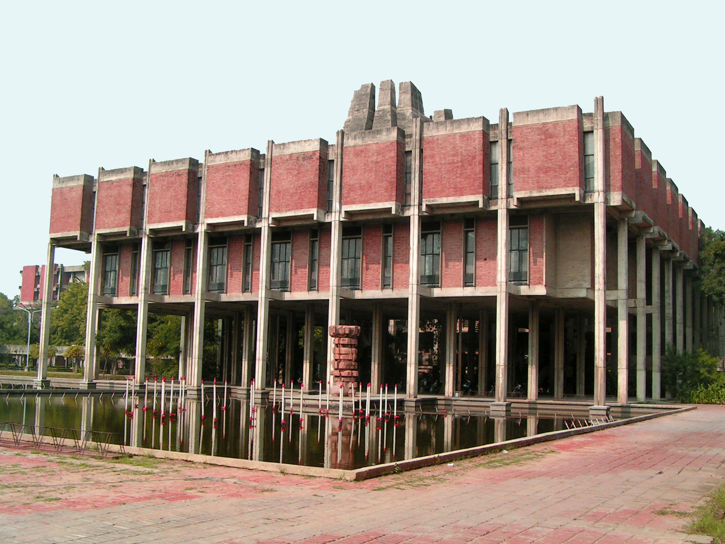
Background:

The photovoltaic cells provide clean, environmental friendly and perennial source of electrical energy. In more than 90% photovoltaic cells and as also in integrated chips (ICs), Silicon is the base material. Silicon based PV technology has made great progress in terms of increase in efficiency and its utilization. Large grid and off grid PV panels are coming up fast world over. By 2040, it is estimated that the share of electric energy generated from PVs will increase from present 1% to about 10%. This may go more than 50% by the end of the present century. Hence, the need of Silicon is likely to increase many fold in future. To meet such challenges, trends are emerging world over to find alternate materials, processes and device structures of right characteristics. Thin films either of silicon, III-V, II-VI group materials, polymers, nano-particles/rods, quantum dots or their hybrids may provide the ultimate solution.

India being a tropical country gets abundant sunlight throughout the year and therefore has a great scope for the photovoltaic energy generation. At present various govt. and private companies like CEL, BEL, BHEL, Moserbaer Photovoltaic, TATA-BP Solar, Maharishi solar Technology and many others are making solar panels using indigenous and imported technologies. Yet another company, Signet Solar India is being launched with GW capacity in the country. To support the industry, there is need for R&D in different aspects of PVs to increase efficiency and usage by reducing costs. The conference aims at bringing together academicians, scientists and technologists at the same platform to meet the challenge.

Conference Topics:
The focus of the conference will be on all the facets of current and emerging PV technologies and related issues like:
- Advances in polysilicon and silicon wafer technology.
- Current Status of Silicon PV: Crystalline, Multi-crystalline and Amorphous.
- High Efficiency III-V and Multi-junction cells.
- Thin Film: CdTe, CIGS, micromorph, crystalline silicon, etc.
- Emerging Technologies: Polymer, Gratzel, Bio, Nano particles/rods based cells.
- Building Integrated PV and developments in Module Technology.
- Concentrator PV
- BOS & Instrumentation related to PV
- Any other issue related to PVs
Conference Structure:
Conference will have paper presentation including both oral and poster sessions, key note lectures and industrial exhibitions. Technical tours of various research facilities will be organized at IIT Kanpur.
Conference Schedule:
Abstract Submission Date: November 07, 2007
Abstract Acceptance: December 06, 2007
Paper Submission Date: February 06, 2008
Abstracts:
Interested authors are requested to submit short abstracts of their proposed papers. Abstract can be either uploaded on the conference website or sent by email to conference email id photovoltaic08@iitk.ac.in

Include: Paper title, names of all the authors, complete postal address, email address of the corresponding author and abstract.

Conference Fees:
Students | 1000 INR
Academics | 3000 INR
Industry | 5000 INR

Location of the conference:

The conference will be held at Indian Institute of Technology Kanpur.

Patron

Prof. S.G. Dhande, Director, IIT Kanpur

Co-Patrons

Prof. Kripa Shanker, Deputy Director, IIT Kanpur
Prof. S.C. Srivastava, Dean R&D, IIT Kanpur

National Advisory Committee

Prof. K.L. Narsimhan, TIFR, Mumbai
Prof. B.M. Arora, TIFR, Mumbai
Prof. A.K. Barua, IACS, Kolkatta
Dr. Prahlada R., CC R&D, DRDO
Prof. Vikram Kumar, Director, NPL, New Delhi
Dr. S.Vathsal, Director, ER & IPR, DRDO
Mr. K. Subramanya, CEO, Tata BP Solar
Mr. Prasanth Sakhamuri, MD, HHV, Bangalore
Dr. S.K. Kaicker, Chairman & MD, CEL, Sahibabad
Mr. Ravi Khanna, CEO, MBPV Ltd, Noida
Dr. Rajeeva Lahri, President, CEO, Signet Solar India
Dr. Bibek Bandyopadhyay, Advisor & Head, SEC, MNRE
Mr. Arun Mishra, GM, Maharishi Solar Technology
Dr. S.S. Sundram, Director, IRDE, Dehra Dun
Dr. K.U. Bhaskar Rao, Director, DMSRDE, Kanpur
Prof. G.N. Mathur, IIT Kanpur, India
Mr. Pradeep Kumar Basu, Director, SSPL, New Delhi
Dr. M.P. Chacharkar, Director, DL, Jodhpur
Prof. K.N. Bhatt, IISc, Bangalore
Prof. T.S. Natrajan, Deptt of Physics, IIT Madras

