PAPER TITLE: LONG TITLES WILL GO ON TO THE SECOND LINE AUTOMATICALLY - KEEP TYPING WITHOUT PRESSING ‘ENTER’

First A. Author^{1*}, Second B. Author, Jr.¹, Third Author², Fourth C. Author³

¹The University of Tokyo, Hongo 7-3-1, Bunkyo-ku, Tokyo 123-4567, Japan
²University of Maryland, College Park, MD 20742, USA
³Shanghai Jiao Tong University, 800 Dong Chuan Rd. Minhang District, Shanghai 200240, China

ABSTRACT This template has been designed for preparing the final proceedings of the 17th International Heat Pipe Conference (IHPC-17), which was held during October 14-17, 2013 at Kanpur, India, All authors are requested to follow these guidelines very closely to achieve uniformity in the presentation of the final conference proceedings. Please start directly writing on this template. When pasting text from some other source, do not use any prior formatting (use ‘paste without formatting’ option). The salient features of the paper format are as follows: body text: times new roman, 11 pt. type size, left and right justified. Main headings: times new roman, all caps, 12 pt. type size, flush left with serial numbering. Page size must be A4 (210 × 297 mm) with a 20 mm borders all round. The primary purpose of this abstract is to highlight the methodology and new research accomplishments in a clear and concise manner. It is also important to indicate briefly the goal, the methods, the results, and conclusions. It should give an account of the most relevant contributions of the paper in a single, stand-alone paragraph not exceeding 250 words. Please do not use abbreviations, diagrams and references in the abstract. It must be stand-alone, complete and clearly understandable, providing comprehensive summary coverage to the contents of the paper.

KEY WORDS: Choose 4-6 appropriate key words that best represent the research contents of your manuscript, separated by a comma (Times New Roman, 10pt, for example - Loop heat pipe, Modeling, Bi-porous wicks, Electronics cooling. Leave two blank lines between keywords and the first major heading, as shown.

1. INTRODUCTION

Leave one blank line when starting a new paragraph (11 pt with no white space above and below, as done here). There is no first line indent on any new paragraphs. It will be assumed that the corresponding author will represent the paper.

The layout of the paper should strictly follow the style of this template document. Papers that do not follow the required format will be returned for corrections. Papers not conforming to the correct format will not be published. Please do not place any blank lines at the top of any page. In addition, please ensure that major/ minor headings are not at the bottom of pages without any body text following it on that page. The manuscript must be converted to a high quality PDF file and sent to ihpc17@iitk.ac.in for final review.

2. LENGTH AND LAYOUT

Papers submitted should be no more than 08 pages for all papers presented during the conference either orally or through a poster (including everything: body text, tables, figures, acknowledgements and references) and no more than 20 pages for the invited keynote papers. Please do not request for longer paper lengths. In addition, try to use even numbers pages for the paper (4, 6, or 8). Very short papers (shorter than 4 pages) will not be accepted. Papers may include color figures (recommended). Each file size should not typically exceed 5 MB (keynote 10 MB) after transforming it to a high quality PDF file.

3. HEADINGS AND EQUATIONS

If your paper is divided into sections and subsections, please use the format adopted here, in which first-level headings are in 12 pt bold capitals, left aligned. Put one blank line before the heading and a blank line after the heading, as has been done here.

3.1 Second-Level Headings

Second level headings should be in 12 pt bold lower case (initial capital), flush left aligned. Put one blank line before the heading and a blank line after the heading, as has been done here.

Third-level headings. Third-level headings should be sparingly used; they should be placed at the beginning of a paragraph, as done here. Capitalize only first letter of the whole sub-heading and make the subhead italic; follow it by a period and two letter spaces; then begin typing the text on the same line and continue the text without indenting again. Leave one line space above.

Equations should be typed in position with appropriate white space (6 pts) above and below to distinguish them from the text. Equations should be numbered as shown below. Preferably use the inbuilt equation editor of MS-Word (e.g. Math-Type). Use Times New Roman, italics, in your math equations. Do not insert equations in a non-editable picture format. Only use Arabic numerals and SI units for all data representation.

Subscripts and superscripts should clearly be typed, and the manuscript should be reviewed carefully to ensure there is no ambiguity in presentation. Numbers and letters that are intended to be subscripts or superscripts should not be aligned with the rest of the text.

(1)
and,
(2)

Do not use punctuation at ends of equations. Align equal signs when equations are stacked with no intervening words. Decimals should always be shown by periods and not by commas or centered dots.

4. FIGURES AND TABLES

Care should be taken to ensure that figures are contained within the typing area. The figures should be good quality JPG/TIFF format with minimum of 150 dpi (300 dpi is actually better). All figures and tables need to be referenced in the text. As a general rule, lettering in the figures should be comparable to that in the text. Color and black/white photographs are allowed in digital format with sufficient resolution to permit high-quality reproduction, and imported into the manuscript.

Figures are centered with a line space above and below the figure. Use or insert .jpg, .tiff, .gif, or similar program files for illustrations. Do not use PowerPoint or graphic constructions as they provide poor quality illustrations.

Figures should be numbered consecutively, e.g., Fig. 1 with a single letter space between the word “Fig.” and the Arabic numeral. Place figures centered on the width of the text page and either at the top or bottom of the page as close as possible to their first mentioned in the text.

For writing the figure caption, type the word “Fig.” and its number followed by one space. Then type the legend single spaced, with an initial capital for the first word and for proper nouns only.

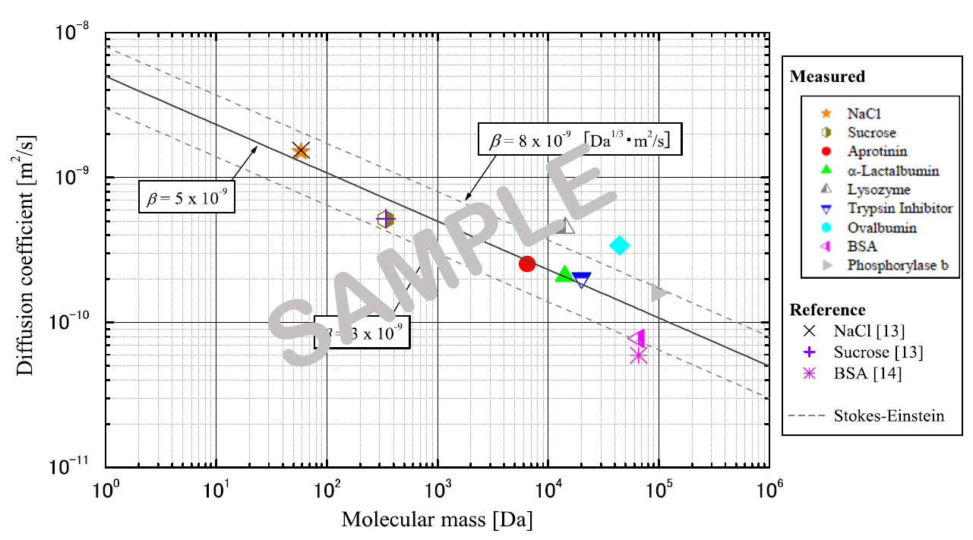

FIG. 1: One line figure captions are centered under the figure. Add one line space (11 font size) above the figure caption.

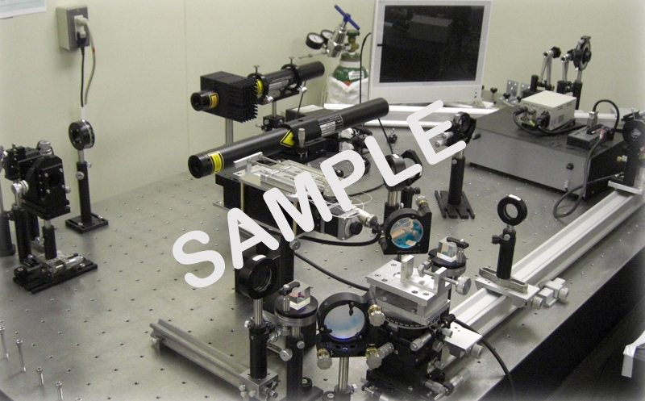

FIG. 2: Two or more lines are flushed left under the figure. Add a line space above the figure caption and one below it, as shown here.

When tables are mentioned in the text, they should be referred to as Table 1, Table 5, i.e., with a single letter space between the word “Table” and the Arabic numeral.

Table captions should appear above the respective table. Each table should have at least a two-line space both above the table and between the table and the start of the following text. The first letter of the word “Table” should be capitalized, followed by the table number and period, then the caption with the first letter of main words capitalized, all centered above the table as shown below. Use horizontal rules above and below to separate title from column heads, ranks within column heads, column heads from table body, and table body from table footnotes or source.

Tables are in Times New Roman, 11 pt. size type, of 1 line heading, centered, if 2 line heading flush left. The table caption goes above the table, with 1 line space above and below the caption. Type size of the body of the table depends on the size of the table, adjust type size accordingly.

TABLE 1: Table captions go above the table, captions that are 2 or more lines are flushed left, 1 line space above and below the caption.

Case | Diameter, d_{b}  (mm) | f  (Hz) | We | St
1 | 0.5 | 731 | 117 | 0.15
2 | 0.5 | 1799 | 620 | 0.16
3 | 1.3 | 198 | 124 | 0.17

5. NON-ENGLISH SPEAKING AUTHORS

Authors from non-English speaking countries are requested to find persons who are competent in English and familiar with the scientific language and can edit their manuscripts before submission. Reviewers may not be relied on to make corrections of English expression, spelling, etc. As there is no editing stage for publication-ready manuscripts, it is the responsibility of authors to ensure that the presentation of their papers reaches the same high level as that of the work they describe.

6. CONCLUSIONS

Present your summary and conclusions in a concise manner here.
Paper Size: A4 (210 × 297 mm).
Margins: 20 mm margins all round as in the Full Paper Template.
Line Spacing: Single-spaced with one blank line between paragraphs. No paragraph indentation.
Justification: Full justification.
Page Numbering: Pages are to be numbered.
Graphs etc: Graphs, tables and photographs are to be included at the top or bottom of the page on which they are first mentioned if possible, on the next page if not, and not gathered together at the end of the paper.

ACKNOWLEDGMENTS

Acknowledgement should be placed immediately following CONCLUSIONS, if necessary.

NOMENCLATURE

As far as possible, use standard nomenclature. In fact, the editors of all the major heat transfer journals have adopted a common list of symbols, which, all authors are encouraged to use. This can be found in the ASME Journal of Heat Transfer, Vol. 121, No. 4, pp. 770-773, November 1999, and is also attached with the e-mail sent to you.

Be dimensionless variable ( - )
Ĉ second variable (s²)
Q_{A} third variable (kJ)
w_{x} fourth variable (m²/s)
f(Ω) function (-)
ζ dimensionless variable ( - )
Ω fifth variable (s-1)

REFERENCES

References to published literature should be quoted in the running body-text using square parentheses containing the family name of the first author (without initials) followed by the year of publication, for example [Faghri, 1995; Hopkins et al., 1999]. In case there are more than two authors you should use the format [Maidanik et al., 1985]. In case you need to start a sentence with an author’s name you should write: Stephan [2000]…. or Boo and Qu [2008]… or Bonjour et al. [2001]… and so on. Reference list at the end of the article should be numbered alphabetically and formatted according to the samples, given hereunder. Incorrectly formatted reference lists will be returned to the author for correction before acceptance. References should be in Times New Roman, 9 pt type size, justified copy, first line flush left, remaining lines indented, as shown below.

Journal Paper
1. Guo, Z.Y., Zhu, H.Y., Liang, X.G., “Entransy - A physical quantity describing heat transfer ability,” Int. J. Heat Mass Transf., 50(13-14), pp. 2545-2556, (2007).
Book
2. Nield, D.A. and Bejan, A., Convection in Porous Media, New York: Springer-Verlag, pp. 125–176, (2005).
E-Books
3. Buyevich, A. and Alexandrov, D.V., Heat Transfer in Dispersions, Connecticut: Begell House, Available at http://www.edata-center.com/ebooks/b7f98f1e271b3e77a.html/ EBooks [accessed May 5, 2005] (2005).
Edited Book
4. Yang, W. and Kim J.H. Eds., Rotating Machinery, New York: Begell House, (1992).
Chapters of Edited Book
5. Nishikawa, K. and Ito, T., “Augmentation of Nucleate Boiling Heat Transfer by Prepared Surfaces,” In T. Mizushina and W.J. Yang, Eds., Heat Transfer in Energy Problems, Washington, D.C.: Hemisphere Publishing, pp. 111–1182, (1982).
Conference Proceedings
6. Ma, T.M., “Effects of Geometrical Shapes of Reentrant Grooves on Boiling Heat Transfer from Porous Surfaces,” Heat Transfer 1986, Proc. of 8th Int. Heat Trans. Conf., vol. 4, pp. 2013–2018, (1987).
Conference Proceedings
7. Kasagi, N., Hasegawa, Y., Fukada, K. and Iwamoto, K., “Control of Turbulent Transport: Less Friction and More Heat Transfer,” Proc. of 13th Int. Heat Trans. Conf., IHTC14-23344, pp. 1-16, (2010).
Dissertation
8. Richmond, J., Steady State Thermal Conductivity, Ph.D. Thesis, University of Connecticut, (2004).
Webpages: Nonperiodical Web Document
9. Author, A.A. and Author, B.B., Title of document. Retrieved month day, year, from http://Web address, (Date of publication). Chapter or Section of a Web document
10. Author, A.A. and Author, B.B. Title of article. In Title of book or larger document (chapter or section number). Retrieved month day, year, from http://www.someaddress.com/full/url/, (Date of publication).
Online Scholarly Journal Article
11. Author, A.A., & Author, B.B., “Title of article,” Title of Journal, volume number. Retrieved month day, year, from http://www.someaddress.com/full/url/, (Date of publication).

